Pacific University Inauguration Symposium for Dr. Coyle
Demystifying Dynamic Assessment: Decision Tree Tutorial
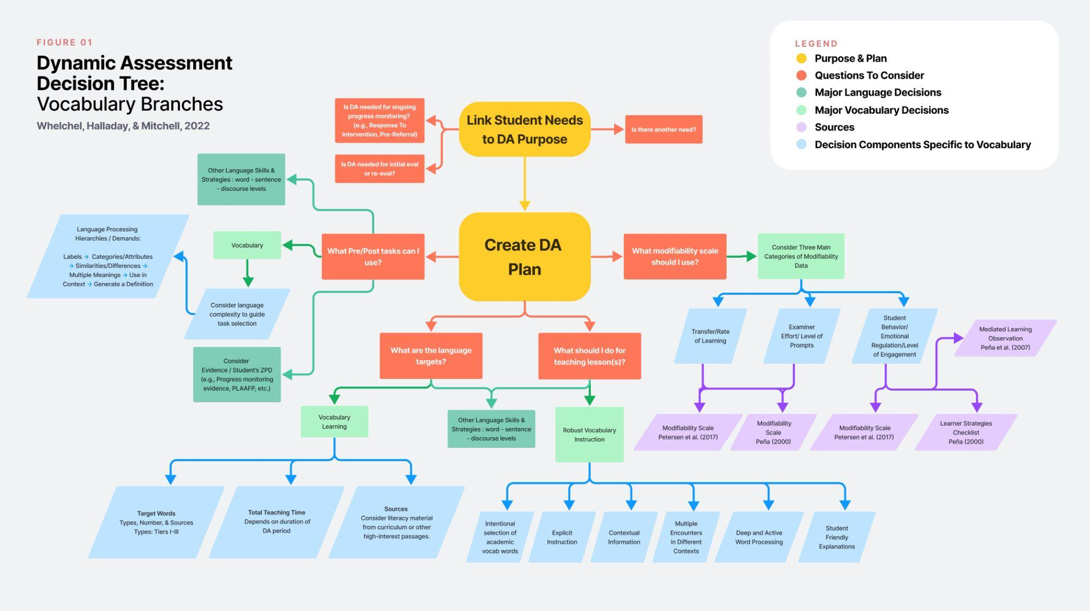
Brittany Halladay, B.S., Taylor Whelchel, B.A., & Mary Mitchell, PhD, CCC-SLP
References for Modifiability Scales
(Search on Google Scholar & article is downloadable for free)

- Modifiability Scale & Learning Strategies Checklist
See Peña, E. D. (2000). Measurement of modifiability in children from culturally and linguistically diverse backgrounds. Communication Disorders Quarterly, 21(2), 87–97. https://doi.org/10.1177/152574010002100203

- Mediated Learning Observation
See Peña, E. D., Resendiz, Maria, & Gillam, R. (2007). The role of clinical judgements of modifiability in the diagnosis of language impairment. Advances in Speech-Language Pathology, 9(4), 332-345. https://doi.org/10.1080/14417040701413738

- Postteaching Modifiability Scale
See Petersen, D. B., Tonn, P., Spencer, T. D., & Foster, M. E. (2020). The classification accuracy of a dynamic assessment of inferential word learning for bilingual English/Spanish-speaking school age children. Language, Speech, and Hearing Services in Schools, 51(1), 144–164. https://doi.org/10.1044/2019_LSHSS-18-0129

References for Dynamic Assessment Systematic Review & Meta-Analysis

Bamford, C. K., Masso, S., Baker, E., & Ballard, K., J. (2022). Dynamic assessment for children
with communication disorders: A systematic scoping review and framework. American Journal of Speech-Language Pathology, 31, 1878-1893. https://pubs.asha.org/doi/10.1044/2022_AJSLP-21-00349

Hunt, E., Nang, C., Meldrum, S., & Armstrong, E. (2022). Can dynamic assessment identify
language disorder in multilingual children? Clinical applications from a systematic review. Language, Speech, and Hearing Services in Schools, 53, 598-625. https://pubs.asha.org/doi/10.1044/2021_LSHSS-21-00094

Orellana, C. I., Wada, R., & Gillam, R. (2019). The use of dynamic assessment for the diagnosis
of language disorders in bilingual children: A meta-analysis. American Journal of Speech-Language Pathology, 28, 1298-1317. https://doi.org/10.1044/2019_AJSLP-18-0202

References for Tutorials

Castilla-Earls, A., Bedore, L., Rojas, R., Fabiano-Smith, L., Pruitt-Lord, S., Adelaida Restrepo,
M., & Peña, E. (2020). Beyond scores: Using converging evidence to determine speech and language services eligibility for dual language learners. American Journal of Speech-Language Pathology and Audiology, 29, 1116-1132. https://doi.org/10.1044/2020_AJSLP-19-00179

Mitchell, M. P. (2021, November 18). Designing dynamic assessment for vocabulary. Poster
session at the American Speech-Language-Hearing Association National Convention, Washington DC.

Elizabeth Pena’s professional development modules through ASHA: https://www.asha.org/practice/multicultural/dynamic-assessment/

Bender, Franklin W. (n.d.). University of Oregon Dynamic Assessment (Overview of Tools)
https://coe.uoregon.edu/cds/files/2016/04/Dynamic-Assessment-Info-Protocol-and-Scoring-Criteria.pdf

Additional Resources

ReadWorks
NewsELA
Leveled Literacy
Wonderopolis

